**Name: Sreelakshmi Madhusoodhanan**

**Roll No: 39**

**Batch: RMCA**

**Date:07-06-2022**

**Object Oriented Programming LAB**

**Experiment No.: 26**

**Aim**

Maintain a list of Strings using ArrayList from collection framework, perform built-in

Operations

**Procedures**

**Source Code**

import java.util.*;

public class arraylist{

public static void main(String[] args) {

ArrayList<String> arrayList= new ArrayList<>();

arrayList.add("Aravind");

arrayList.add("William");

arrayList.add("Tejas");

arrayList.add("Nebin");

System.out.println("The elements of the arraylist is - "+arrayList);

Collections.sort(arrayList);

System.out.println("\nThe ArrayList Sort : "+arrayList); // ArrayList Sort

Collections.addAll(arrayList,"Vivek","Vikram","Shantanu","Willson","Godwin");

System.out.println("\nAdding new items in the arraylist is : "+arrayList); // ArrayList AddAll

Collections.sort(arrayList, Collections.reverseOrder()); //Arraylist in reverse order

System.out.println("\nThe reverse order of the arraylist : "+arrayList);

System.out.println("\nThe maximum element of the arraylist : "+Collections.max(arrayList)); //Max elements in the arraylist

}

}

**Output**

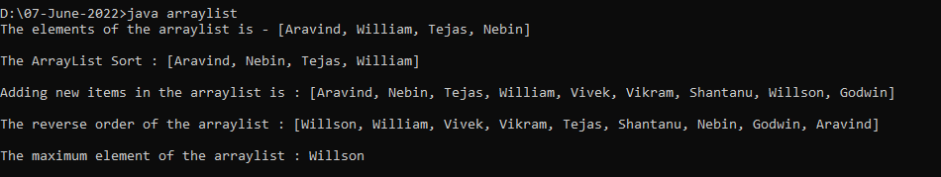

**Experiment No: 27**

**Name: Sreelakshmi Madhusoodhanan**

**Roll No:39**

**Batch: RMCA B**

**Date:07/06/2022**

**Aim**

Program to demonstrate the creation of queue object using the Priority Queue class.

**Procedure**

import java.util.PriorityQueue;

public class CreationQueue {

public static void main(String[] args) {

PriorityQueue <Integer> pq = new PriorityQueue<>();

pq.add(10);

pq.add(13);

pq.add(15);

System.out.println("Elements are:");

System.out.println(pq);

System.out.println("Peek element is:");

System.out.println(pq.peek());

System.out.println("Removed element:");

System.out.println(pq.poll());

System.out.println("New peek element:");

System.out.println(pq.peek());

}

}

**Output Screenshot**

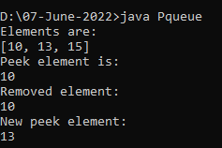

**Experiment No: 28**

**Name: Sreelakshmi Madhusoodhanan**

**Roll No:39**

**Batch: RMCA B**

**Date:07/06/2022**

**Aim**

Program to demonstrate the addition and deletion of elements in deque.

**Procedure**

import java.util.*;

class deque

{

public static void main(String[] args)

{

Deque<String> deque = new LinkedList<String>();

deque.add("Java");

deque.addFirst("Python");

deque.addLast("Datastructure");

deque.push("Web-programming");

deque.offer("Networking");

deque.offerFirst("DBMS");

System.out.println(deque + "\n");

deque.removeFirst();

deque.removeLast();

System.out.println("Deque after removing " + "first and last: " + deque);

}

}

**Output Screenshot**

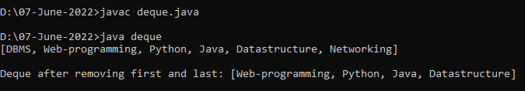

**Experiment No: 29**

**Name: Sreelakshmi Madhusoodhanan**

**Roll No:39**

**Batch: RMCA B**

**Date:07/06/2022**

**Aim**

Write a Java program to compare two hash set.

**Procedure**

import java.util.*;

public class Hash {

public static void main(String[] args) {

HashSet<String> h_set = new HashSet<String>();

h_set.add("Red");

h_set.add("Green");

h_set.add("Black");

h_set.add("White");

HashSet<String>h_set2 = new HashSet<String>();

h_set2.add("Red");

h_set2.add("Pink");

h_set2.add("Black");

h_set2.add("Orange");

for (String element : h_set2){

System.out.println(h_set.contains(element) ? "Yes" : "No");

}

}

}

**Output Screenshot**

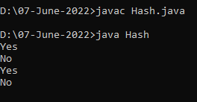

**Experiment No: 30**

**Name: Sreelakshmi Madhusoodhanan**

**Roll No:39**

**Batch: RMCA B**

**Date:07/06/2022**

**Aim**

Program to demonstrate the working of Map interface by adding, changing and removing elements.

**Procedure**

import java.util.*;

class HashMapDemo {

public static void main(String args[]) {

Map<String, Integer> hm = new HashMap<String, Integer>();

hm.put("Anu", new Integer(1));

hm.put("sinu", new Integer(2));

hm.put("Jinu", new Integer(3));

for (Map.Entry<String, Integer> me : hm.entrySet()) {

System.out.print(me.getKey() + ":");

System.out.println(me.getValue());

}

}

}

**Output Screenshot**

